Build your own Sorting Hat!

In this hands on workshop we’ll be building our own Harry Potter sorting hat, using JavaScript and Microsoft Cognitive Services.

We’re going to be building our own version of: <http://sortinghattutorial.azurewebsites.net/>

# Prerequisites

1. **Visual Studio Code**  
   The first thing we’re going to need is a place to create and edit our code. I recommend using Visual Studio Code, but feel free to use something you’re more comfortable with (Notepad++, Atom, etc)
   1. To install Visual Studio Code, go to <http://code.visualstudio.com> and click the download button. Once it’s downloaded, run the file to install

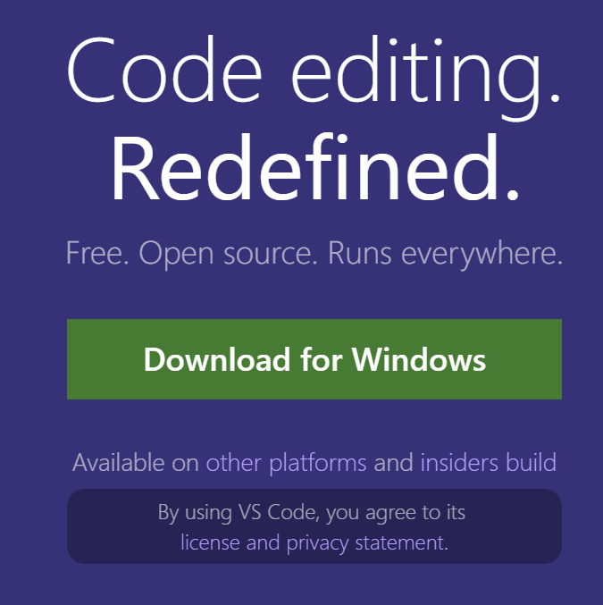

1. **Microsoft Account** (liveID)  
   We’ll also need a Microsoft account to get an API key for Microsoft Cognitive Services (which will be the brain behind our sorting hat
   1. Not sure if you have one? Try going to <http://login.live.com>
   2. Register for one at <http://signup.live.com>
2. **Internet Connection**

We’ll need an internet connection to connect to the sorting hat. If you’ve completed prerequisites 1&2, you probably have one.

# Let’s get started

1. In your favorite web browser, go to <http://aka.ms/SortingHatTutorial> - it’ll look like this

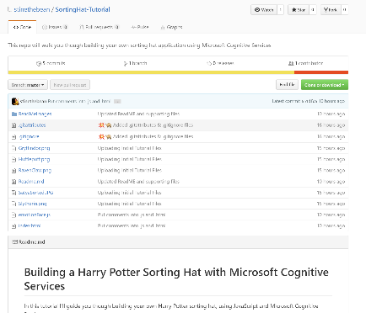

1. Scroll down the page, to where it says **Getting an API key**, that’s where we need to start.  
   Walk through the Github page and make sure you complete the following things:
   1. Getting an API key
   2. The Starter Code
   3. **TODO 1** Where it says "YOUR-API-KEY-HERE"
   4. **TODO 2**You should think
   5. **TODO 3**Once you create a new algorithm
   6. (Optional) Publishing to the Internet!
2. Then you’ll have built your own Sorting Hat! Yay!

# Looking for learn even more?

Check out the following resources:

* Minecraft Hour of Code – Use blocks of code to take Alex on an adventure through a Minecraft world  
  <http://code.org/mc>
* Touch Develop: Jumping Bird – Build your own flappy bird clone!  
  <https://aka.ms/digigirlzflappybird>
* Microsoft YouthSpark – tools and training from Microsoft to help you express what you love through computer science  
  <https://www.microsoft.com/about/philanthropies/youthspark/youthsparkhub/> (or just search for YouthSpark)
* Code Academy – looking to learn more javascript? I learned from CodeAcademy, it’s free!  
  <https://www.codecademy.com/>

If you had fun and want to share some feedback, or ask some questions,   
Contact me at:

Christine Matheney

@matheneyc

[Christine.Matheney@microsoft.com](mailto:Christine.Matheney@microsoft.com)